OOAD WITH JAVA DOCUMENTATION
Student Names: Refilwe Rakhudu
Student ID: CSE24-095
Date: 17/11/2025
Program of study: CSE
Year of Study: Year 2

OOAD WITH JAVA
BANKING SYSTEM TESTING
Signing in
The dashboard that starts allows the teller to sign or the user to sign in, it depends on the user name they have entered.
The teller enters their own information then it takes them to teller dashboard. The user once created by the teller enters their own information too and it takes them to the user dashboard.
When either of the users have entered the wrong details it write that the users has entered the wrong credentials
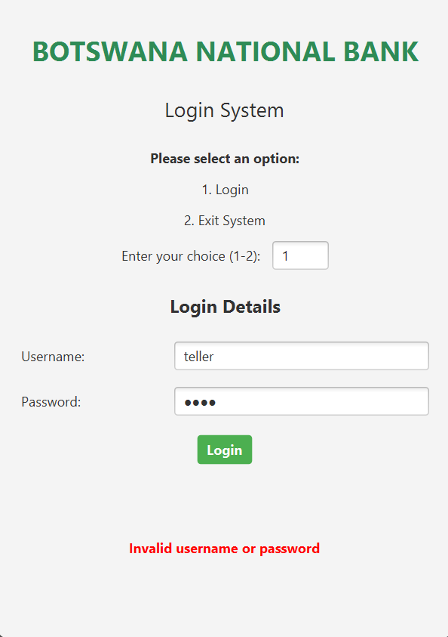
TELLER DASHBOARD
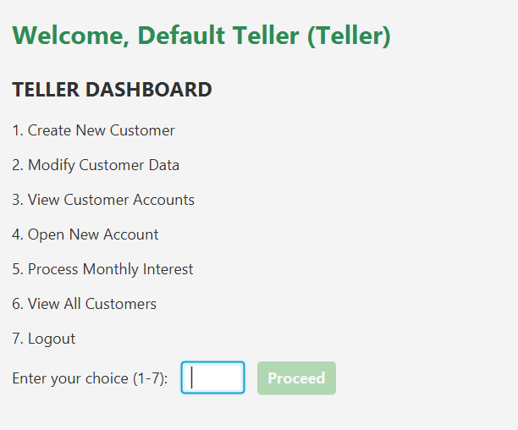
CUSTOMER DASHBOARD
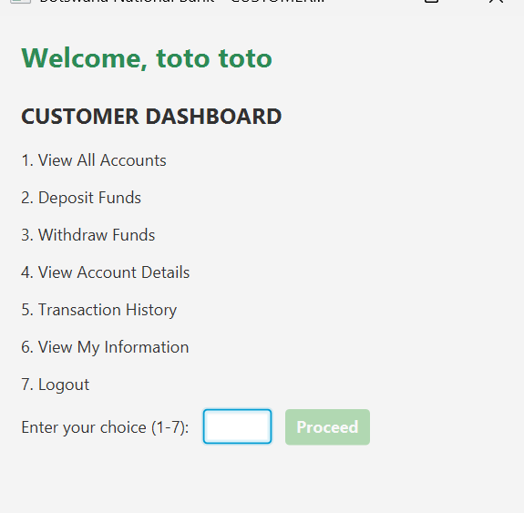
CREATION OF USER AND THEIR BANKING ACCOUNT

From the teller dashboard select the first option (1) create new customer. Then you enter their details: Their first name, Surname, Email, Username and their password
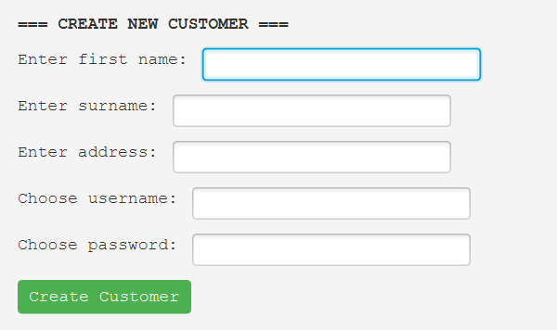

Now for the creation of the user’s account
You select the forth (4) open new account, after that you select the user you want to create an account for an existing account
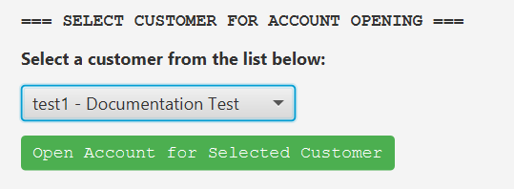
You then select the user type. Individual or business, after that you select the account type savings, investment or cheque. Investment has an initial deposit of 500 BWP, savings has 50BWP while cheque can be created without an initial deposit.

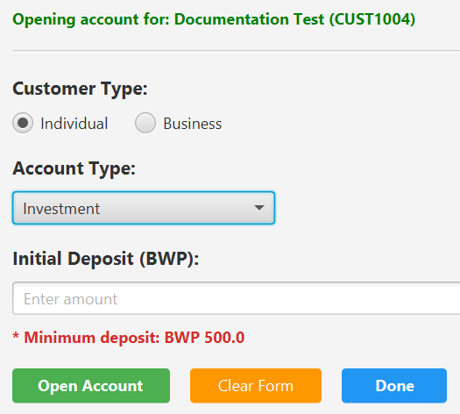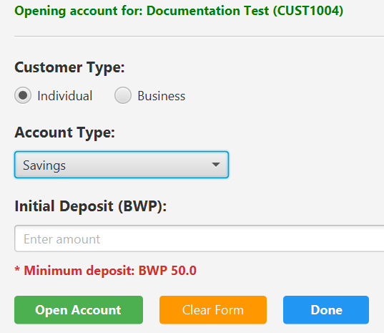
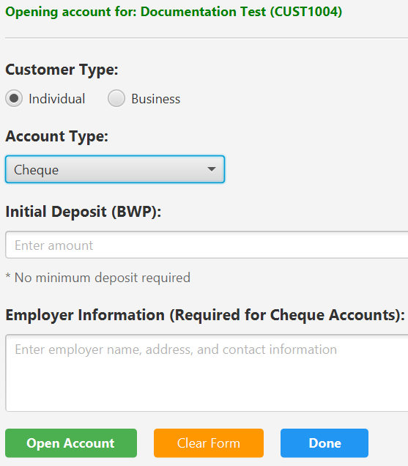

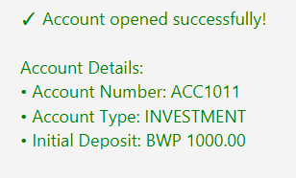

Now to open the Customer dashboard

The user is able to view their accounts, deposit and withdraw from their various accounts
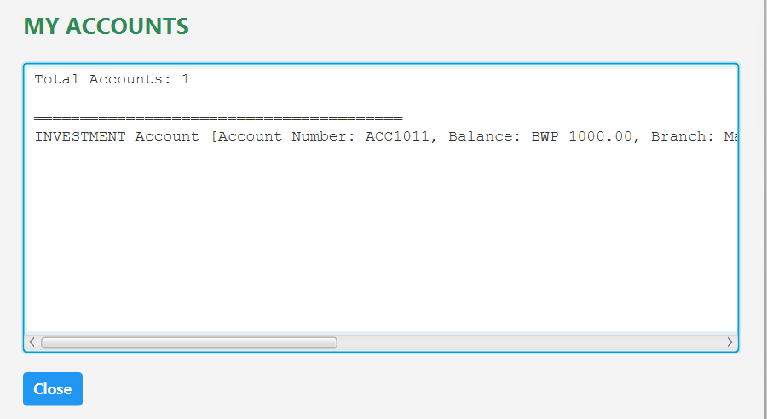
Deposit into investment account.
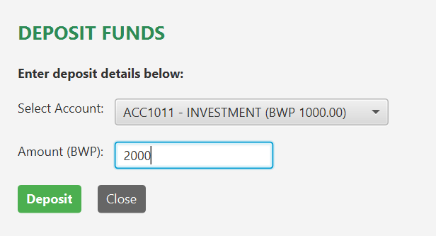
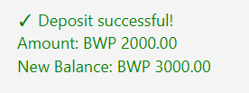
Withdrawal from the investment account.
